Name_______THIS IS A CLASS COPY_________ Class___DON’T WRITE ON ME_____ Date____________
Solve each system of equations for y=mx+b and then graph. Determine if the system has one, none, or infinite solutions.
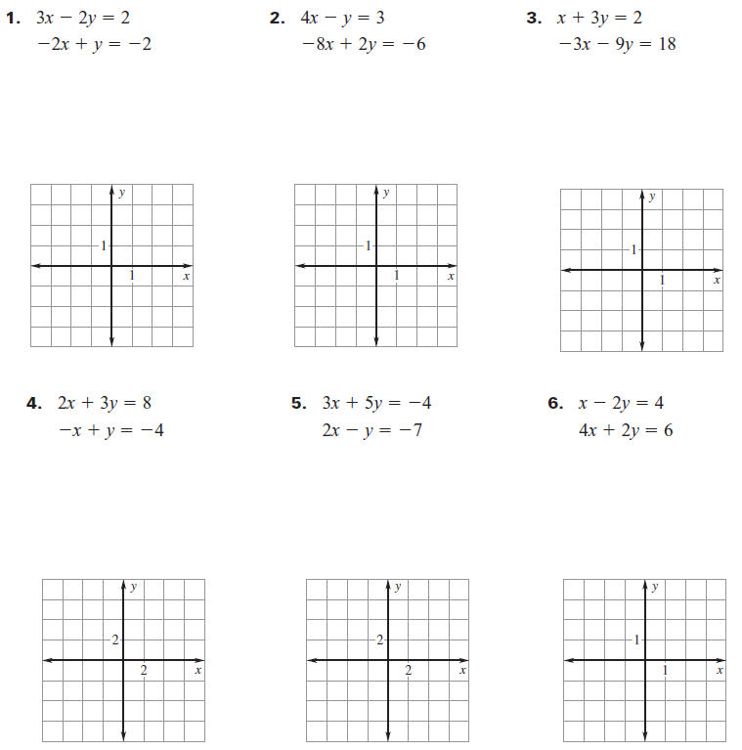

7. When can you tell if a system has no solution, one solution, or infinitely many solutions before you graph? Can you give an example of each?

