- Graphing and Quadratic Forms | - Solving, x-intercepts, zeros, or roots
- Standard to Vertex – Complete the square  - Standard to Intercept – Factor  - Vertex to Standard – FOIL + Simplify  - Intercept to Standard – FOIL  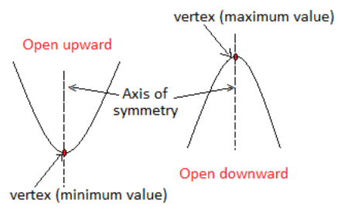 | - Factor -> Separate -> Solve  $$x^{2}+5x-24=0→\left(x+8\right)\left(x-3\right)=0 \\ →x-8=0 and x+3=0→x=8,x=-3$$  - $x=\frac{-b±\sqrt{b^{2}-4ac}}{2a}$  - Complete the square using a magical c value of $c=({\frac{b}{2})}^{2}$ and then adding/subtracting to make your magic c value.
- Factoring  - GCF then Tic-Tac-Toe $4x^{2}-12x+8 is 4(x^{2}-3x+2)$ and factors to $4(x-2)(x-1)$.  - GCF and Difference of Squares $32x^{2}-18 → 2(16x^{2}-9)$ and factors to $2\left(4x+3\right)\left(4x-3\right).$ | - Radicals  - $\sqrt{6}*\sqrt{3}=\sqrt{18}=\sqrt{9}\sqrt{2}=3\sqrt{2}$  - $\sqrt{\frac{11}{9}}= \frac{\sqrt{11}}{\sqrt{9}}= \frac{\sqrt{11}}{3}$  - $\frac{5}{3-\sqrt{2}}* \frac{3+\sqrt{2}}{3+\sqrt{2}}=\frac{15+5\sqrt{2}}{9-\sqrt{4}}=\frac{15+5\sqrt{2}}{9-2}=\frac{15+5\sqrt{2}}{7}$
- Imaginary Numbers | - Writing Quadratic Equations
- Adding/Subtracting – Just like x’s $\left(4+2i\right)+\left(6-8i\right)=10-6i$  - ${(4-5i)}^{2}$ –Change and FOIL $\left(4-5i\right)\left(4-5i\right)=16-20i-20i+25i^{2}$ = $16-40i+25\left(-1\right)=-9-40i$  - $\frac{5}{3-2i}* \frac{3+2i}{3+2i}=\frac{15+10i}{9-{4i}^{2}}=\frac{15+10i}{9+4}=\frac{15+10i}{13}$ | - For vertex form use $y=a{(x-h)}^{2}+k$  - For Intercept form use $y=a(x-p)(x-q)$
- Word Problem #1 | - Word Problem #2
The dimensions of the old stage at the concert hall were 30 feet wide and 15 feet deep. The new stage has a total area of 1000 square feet. The dimensions of the new stage were created by adding the same distance x to the width and the depth of the old stage dimensions. What is the value of x?  (Side 1)(Side 2) = New Area  FOIL  FACTOR  Separate + Solve | A contestant tosses a horseshoe from one pit to another with an initial vertical velocity of 50 feet per second. The horseshoe is released 3 feet above the ground. Use the model h = − 16t² + 50t + 3 where h is the height (in feet) and t is the time (in seconds) to tell how long the horseshoe was in the air when it’s 2 feet high.  Use quadratic formula.

