Name______________________________________________ Class________________ Date________
Graphing in standard form review
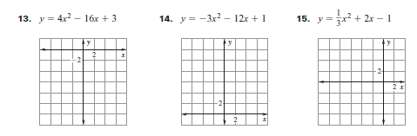
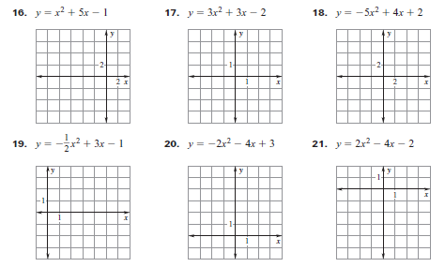

Graphing in Vertex form.
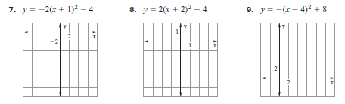

Factor and find the zeros.

Zeros: Zeros: Zeros:

Zeros: Zeros: Zeros:

Zeros: Zeros: Zeros:

Zeros: Zeros: Zeros:

