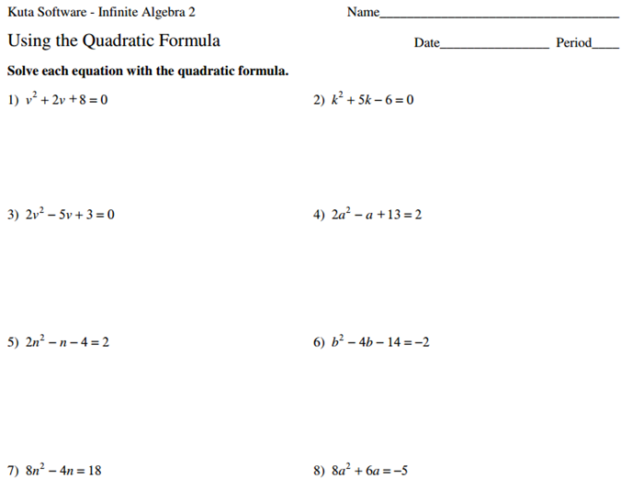
Practicing Imaginary Numbers:
11) $\left(2-6i\right)+\left(-4+3i\right)$ 12) $\left(-8+2i\right)-\left(1-3i\right)$ 13) $\left(11-2i\right)-\left(-3+10i\right)$
14) $\left(8+5i\right)\left(-7+2i\right)$ 15) ${(5-12i)}^{2}$ 16) ${(2+5i)}^{2}$
17) You kick a soccer ball that models the equations $y={-16t}^{2}+128t$ where t is time in seconds and y is vertical height.
a) Graph this equation.
b) At what times is the ball touching the ground? Why is this called the reasonable domain?
c) Write and solve an inequality to find what times the soccer ball is greater than 50 ft.

