Name This is a class copy___________________ Class___________________ Date________________
1. In y=mx+b which are variables and which are supposed to be numbers?
What does m and b stand for?
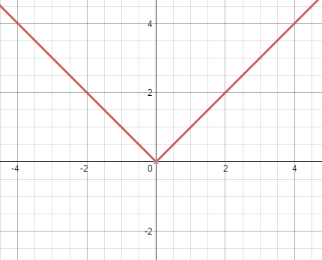
2. In $y={ax}^{2}+bx+c$ which are variables and which are supposed to be numbers?
How do you use a, b, and c?
3. To the left here is the graph of $y=|x|$.
a) I want you to draw a new graph that is moved 3 units left,
5 units up, and stretched vertically by 2.
b) Write the equation that represents this change.
4. Explain what each number represents in the following equation.
$$y=6f\left(x+1\right)-3$$
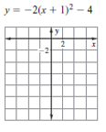
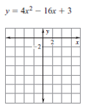
5. Graph the following: 6. Graph the following:
7. Factor and find the zeros.
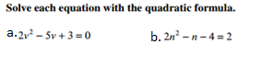
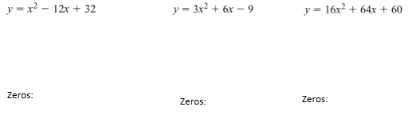
8. 9. Simplify $\left(-8+2i\right)-\left(1-3i\right)$
10. Simplify ${(5-12i)}^{2}$
11. You kick a soccer ball that models the equations $y={-16t}^{2}+128t$ where t is time in seconds and y is vertical height.
a) Graph this equation.
b) At what times is the ball touching the ground? Why is this called the reasonable domain?
c) Write and solve an inequality to find what times the soccer ball is greater than 50 ft.

