Graphing and Quadratic Forms
- Change $x^{2}-10x+16=y$ into vertex and intercept form and then graph the parabola.
- Change ${(x-4)}^{2}+16=y$ into standard form and then graph the parabola.
- Change $(x+3)(x-11)=y$ into standard form.

Solving, x-intercepts, zeros, and roots.
- Solve by factoring separating and solving $x^{2}-10x+16=0$
- Solve by using the quadratic formula ${5x}^{2}-7x=-13$
- Solve by completing the square $x^{2}-10x+9=0$

Factoring
- $x^{2}-5x-66$
- ${13x}^{2}-39x-52$
- $x^{2}-121$
- ${20x}^{2}-245$
Radicals
- $2\sqrt{28}*3\sqrt{8}$
- $\sqrt{\frac{25}{36}}$
- $\frac{7}{2-\sqrt{3}}$
Imaginary Numbers
- $\left(-6+2i\right)-(5-2i)$
- ${(2-5i)}^{2}$
- $\frac{7}{2-3i}$

Writing Quadratic Equations
- Write an equation in vertex form of the graph. 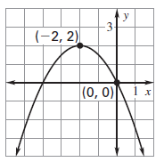
- Write and equation in intercept form of the graph. 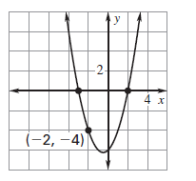
Word Problem #1
- The dimensions of the old stage at the concert hall were 30 feet wide and 15 feet deep. The new stage has a total area of 1000 square feet. The dimensions of the new stage were created by adding the same distance x to the width and the depth of the old stage dimensions. What is the value of x?

Word Problem #2
- A contestant tosses a horseshoe from one pit to another with an initial vertical velocity of 50 feet per second. The horseshoe is released 3 feet above the ground. Use the model h = − 16t² + 50t + 3 where h is the height (in feet) and t is the time (in seconds) to tell how long the horseshoe was in the air when it’s 2 feet high.

